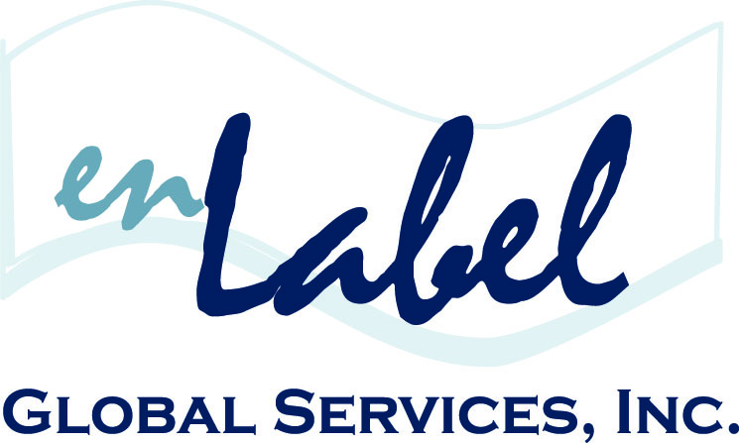
FOR IMMIDEATE RELEASE
Media Contact
Christine Tournas
enLabel Global Services
(617) 419-2400
ctournas@enlabel.com

ENLABEL GLOBAL SERVICES GOLD SPONSOR OF 4th SEMI-ANNUAL
MEDICAL DEVICE & DIAGNOSTIC LABELING CONFERENCE

April 25-26, 2016 | Alexandria, VA

BOSTON, February 2016. enLabel Global Services is the second-time Gold Sponsor of the 4th Semi-Annual Medical Device and Diagnostics Labeling Conference, hosted by Q1 Productions, on April 25-26, in Alexandria, Virginia.

The conference will focus on complying with evolving labeling & UDI requirements on the international level, as well as focusing on enhancing operational management of label development & approval and exploring software & tools to support labeling needs.

Ken Legault, VP Sales & Business Development, enLabel Global Services, will present a case study Keynote presentation on Building the Source of Truth for Global Labeling Content, which will focus on the importance of planning and aligning with best practices, leveraging or building the source of truth, harmonizing the global process and measuring success.

Additionally, Legault, will lead an interactive workshop where participants will discover how to introduce intelligent electronic assets, such as IFUs and Product Manuals, to the global marketplace via any web-based device.

Other industry experts, regulatory bodies and standard organizations will also provide professional insight via engaging presentations, specialized breakout sessions and panel discussions.

For additional event information, please visit, www.q1productions.com.
# # #

About enLabel Global Services
Founded in 2005, enLabel Global Services has completely changed the pace of the global enterprise packaging industry, by providing the World’s only end-to-end Integrated Packaging Management (IPM) Software Platform. Headquartered in the historical North End of Boston, MA, enLabel Global Services is a Technology and Consulting Services Company that works diligently with manufacturers and distributors in the Medical Device, Biotech, Pharmaceutical, Aerospace and Petro/Chemical industries. With a state-of-the-art streamlined approach to the global packaging process, enLabel is an industry leader in achieving zero-defect packaging, worldwide. For more information on the enLabel IPM Software Platform, as well as global compliance and additional services, please visit enLabel.com.

