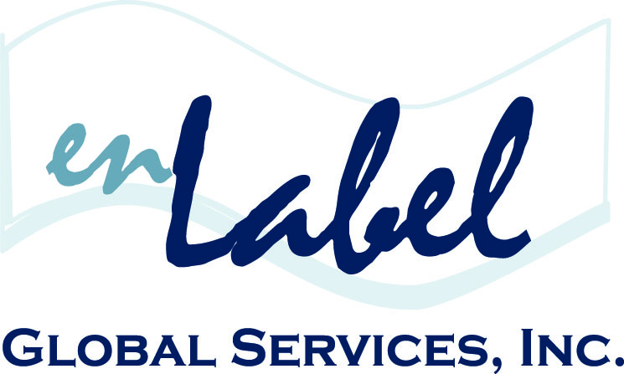
FOR IMMIDEATE RELEASE
Media Contact
Christine Tournas
enLabel Global Services
(617) 419-2400
ctournas@enlabel.com

ENLABEL GLOBAL SERVICES GOLD SPONSOR OF 3rd SEMI-ANNUAL
MEDICAL DEVICE & DIAGNOSTIC LABELING CONFERENCE

September 24-25, 2015 | San Diego, CA

BOSTON, September 2015. enLabel Global Services is the Gold Sponsor of the 3rd Semi-Annual Medical Device and Diagnostics Labeling Conference, hosted by Q1 Productions, on September 24-25, in San Diego, California.

The conference will focus on the importance of maximizing Corporate UDI strategies, optimizing Label Translation & Content Localization strategies, all while streamlining Label Approval Operations and minimizing Human Errors.

Ken Legault, VP Sales & Business Development, enLabel Global Services, accompanied by Riënts van Werven, Execution Excellence Manager, Packaging & Product Labeling, ETHICON, will present the Keynote presentation on the Development & Execution of an Efficient Global Labeling Strategy.

Additionally, Legault, accompanied by Melissa Finocchio, Director, Global Product Labeling & Documentation, BIOMERIEUX FRANCE - GLOBAL HQ, will lead a Panel Discussion on the Pros & Cons of Connecting Labeling to Other Corporate Departments.

Other industry experts, regulatory bodies and standard organizations will also provide professional insight via engaging presentations, specialized breakout sessions and interactive workshops.

For additional event information, please visit, www.q1productions.com.

# # #

About enLabel Global Services
Founded in 2005, enLabel Global Services has completely changed the pace of the global enterprise packaging industry, by providing the World’s only end-to-end Integrated Packaging Management (IPM) Software Platform. Headquartered in the historical North End of Boston, MA, enLabel Global Services is a Technology and Consulting Services Company that works diligently with manufacturers and distributors in the Medical Device, Biotech, Pharmaceutical, Aerospace and Petro/Chemical industries. With a state-of-the-art streamlined approach to the global packaging process, enLabel is an industry leader in achieving zero-defect packaging, worldwide. For more information on the enLabel IPM Software Platform, as well as global compliance and additional services, please visit enLabel.com.

